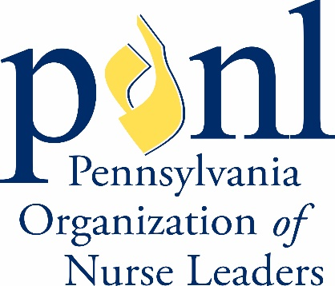
Pennsylvania Organization of Nurse Leaders 2024 Annual Nursing Leadership Conference
Hilton Harrisburg | Harrisburg, PA September 26-27, 2024

CALL FOR ABSTRACTS - RAPID ROUNDTABLE PRESENTATIONS
Join PONL for our 2024 Annual Nursing Leadership Conference in Harrisburg, PA, as we celebrate nurse leaders' individual and collective achievements from across the Commonwealth. This two-day program includes plenary sessions, rapid roundtable presentations, program sponsor and vendor exhibits, networking reception, and the annual PONL business meeting.
PONL invites nurse leaders, ranging from novice to expert, from various specialties, to share best practices across the care continuum. Rapid Roundtable Abstracts should reflect an implemented nursing leadership intervention that reflects an innovative approach, special project, evidence-based practice, or research study.
A peer review panel will select abstract submissions that demonstrate excellence in nursing leadership and meet the guidelines set forth below. Selected applicants will give a 10-minute presentation on their project to attendees in a roundtable setting, with an additional 5 minutes allotted for Q&A (15 minutes total). Attendees will rotate among the Rapid Roundtable Presentations which will be repeated for multiple rotations. Primary presenters may have one additional colleague to present with them.

Abstract Guidelines:

PONL is a Nursing Leadership organization seeking submissions that demonstrate success and excellence in leadership. Therefore, clinically oriented submissions will not be considered for review.
Special consideration will be given to abstracts that help PONL meet our strategic objectives and address any of the following areas:
Area | Strategic Objective
Innovative care delivery models | Advance and promote Nurse-driven models
Recruitment, retention, engagement strategies | Lead, influence, support Healthcare workforce
Leadership in a virtual world | Advance nursing leadership
Virtual health opportunities, approaches, successes | Advance and promote nurse-driven models
Effective strategies for leading change | Advance nursing leadership
Advocating for vulnerable populations | Inspire and promote nurses to achieve health equity

Abstract requirements (300 words or less [excluding title, presenter information, and references]):

- Identification of the problem, gap, issue, or project.
- Description of the method(s) used to address the problem, gap, issue, or project.
- Description of the findings, conclusions, or solutions.
- Evaluation of the relevance of the innovations, special project, evidence-based practice, research study, or strategies that positively influence nursing leadership.
- Recommendations related to replication and adaptability of the project findings to other organizations and healthcare settings.
- Citation of supporting references in APA format that are no more than 5 years old. Include links to references.
All submissions are subject to blinded peer review.

Abstract Submission:

Complete the PONL Rapid Round Table Presentation Abstract Submission
- Complete the PONL Educational Offering Planning Form to reflect the education that will be provided on the topic submitted.

Deadline to Submit Abstract:
Abstracts must be submitted via the link below no later than Monday, May 20, 2024, 11:59 p.m. Eastern Time. Submissions will not be accepted after the deadline.

Notification:
All primary presenters will be notified of acceptance decisions on or before June 15, 2024.
All presenters are responsible for conference registration fees and any other expenses incurred. For additional information or assistance, contact PONL Office at admin@ponl.net.

