Dear Prospective Sponsor and Exhibitor,
The Southeastern Pennsylvania Organization of Nurse Leaders (SEPONL) represents approximately 200 nursing leaders from diverse practices across Southeastern Pennsylvania. Our members employ, manage, and influence thousands of nurses and health care workers. Additionally, they are responsible for multi-million dollar operating budgets.
SEPONL hosts two educational conferences each year. We would like to invite you to participate as a sponsor or an exhibitor at any or all of our conferences. Your support is critical to carrying out the mission and goals of the organization.
We have several options for you to select from as a sponsor and/or exhibitor. Enclosed is a schedule of 2020 conference and rate information for sponsor and exhibitor opportunities. We are also offering exhibitors several package options, which include exhibitor space at multiple venues and the opportunity to advertise on our website. Space at our conferences is limited and display space will be reserved on a first-come basis.
We are very grateful for the support of our sponsors. Sponsorship opportunities include sponsoring or co-sponsoring breakfast, lunch, and speakers at any or all of our events. Please let us know of any additional sponsorship ideas that would be meaningful for you.
Don’t miss this opportunity to have your organization increase visibility with nurse leaders throughout Southeastern Pennsylvania. You will meet the nursing decision makers of many hospitals and healthcare facilities. Past sponsors have told us they have found it most valuable to showcase their products and services, and they have benefited from discussions with nurse leaders from across our region.
Should you have any questions or need further information please contact Chaudron Carter, SEPONL Education Committee Chair by phone at 267-606-3868 or e-mail at Chaudron.Carter@tuhs.temple.edu
Thank you for your support and interest in this year’s educational conferences.
Warm regards,
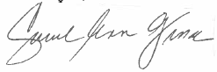
Carol Ann Gioia, DNP, RN, NEA-BC
SEPONL Chair

Reservation for Sponsorship and Exhibitor Opportunities From
Company Name for the Program_________________________________________________
Contact Name/Title____________________________________________________________
Address________________________________ City, State, Zip______________________
Phone_________________________________ Email_____________________________
- Please return the completed form and payment to:
All sponsors will be featured in program material, and on the SEPONL website.
Sponsors who contribute $500 - $1,499 will receive one free program registration, which will include breakfast, breaks, lunch, and CEU credits.
Sponsors who contribute $1,500 or more will receive two free program registrations, and are invited to exhibit their services and/or products during the program breaks and lunch.

Check – make payable to: SEPONL
Nicholle Lawyer
Abington Health Foundation
1200 Old York Road
Abington, PA 19001
(215) 285-3464

- Submit your company description and logo
(high quality jpeg) in an attachment to
Nicholle.Lawyer@jefferson.edu

Please check off below what level of sponsorship you would like to have for this conference.
Breakfast Sponsor $1,000
Breakfast Co-Sponsor $500
Lunch Sponsor $2,000
Lunch Co-Sponsor $1,000
Break Sponsor $ 1,000
Break Co-Sponsor $500
Speaker Sponsor $3,000
Speaker Co-Sponsor $1,500

Please indicate below if you are interested in exhibiting. Exhibit space is limited.
YES, I WOULD LIKE EXHIBIT SPACE FOR THE
April 24, 2020 PROGRAM
(please see above box for additional details)

Name for additional rep_______________________

Host Hotel Information
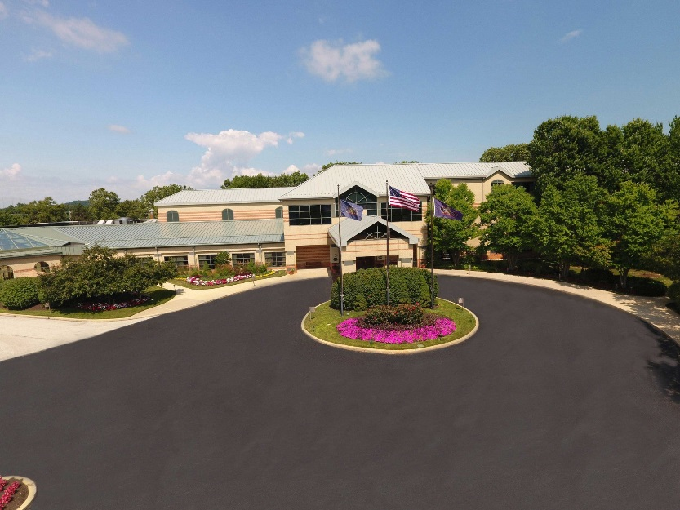

The Desmond Hotel Great Valley
One Liberty Boulevard
Malvern, PA 19355
Reservations: 866-430-2692
Click her for Online Reservations

