2018 SWPONL Officers
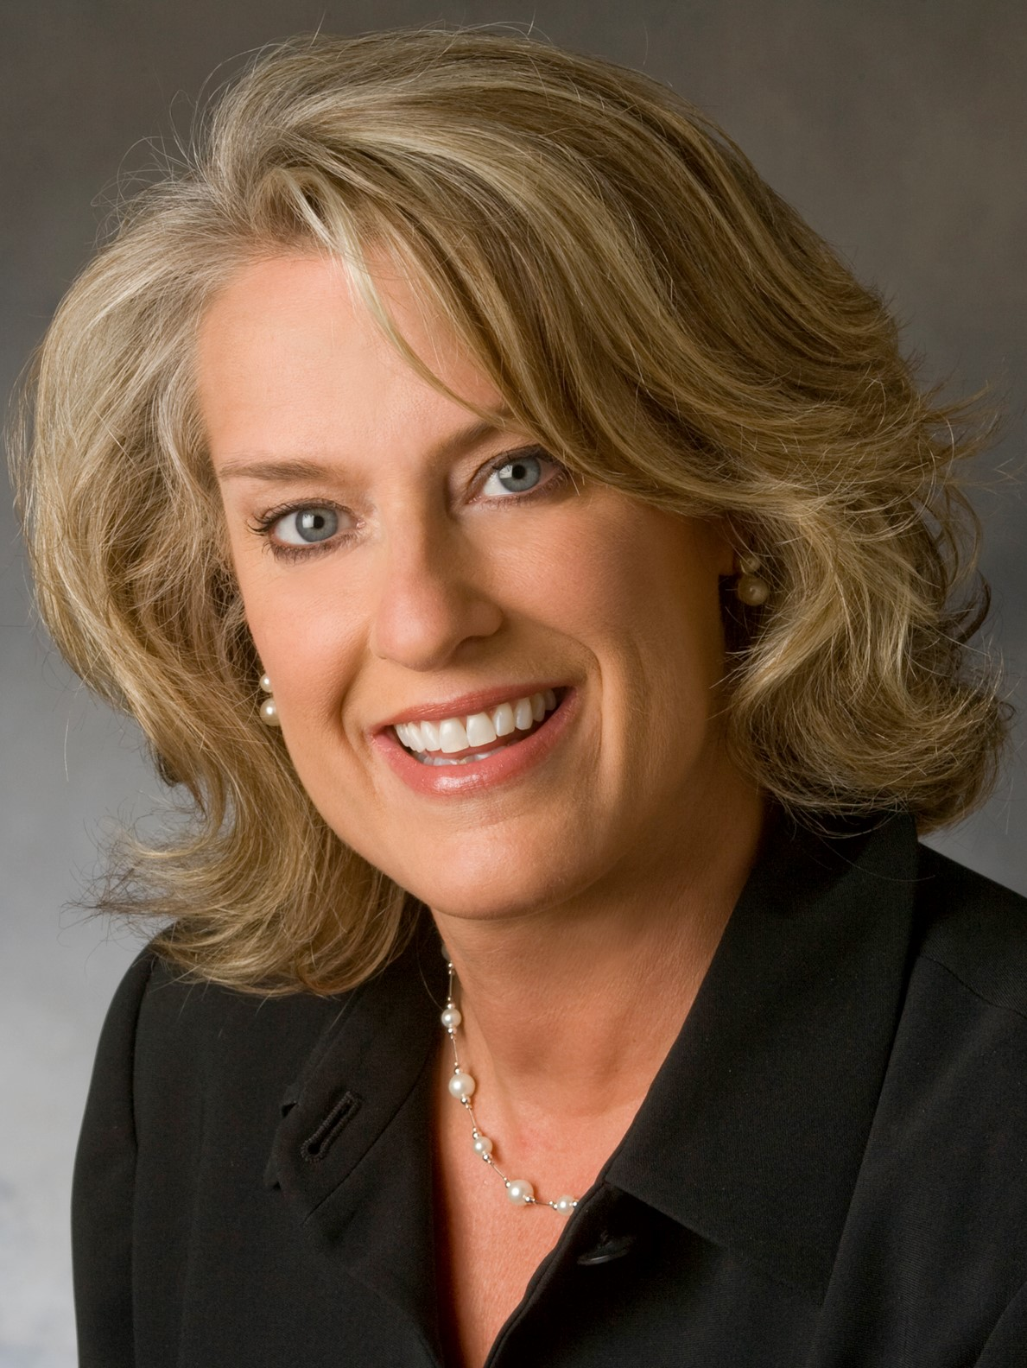  CHAIR  Claire M. Zangerle, DNP, MSN, MBA, RN  Allegheny Health Network  claire.zangerle@ahn.org | 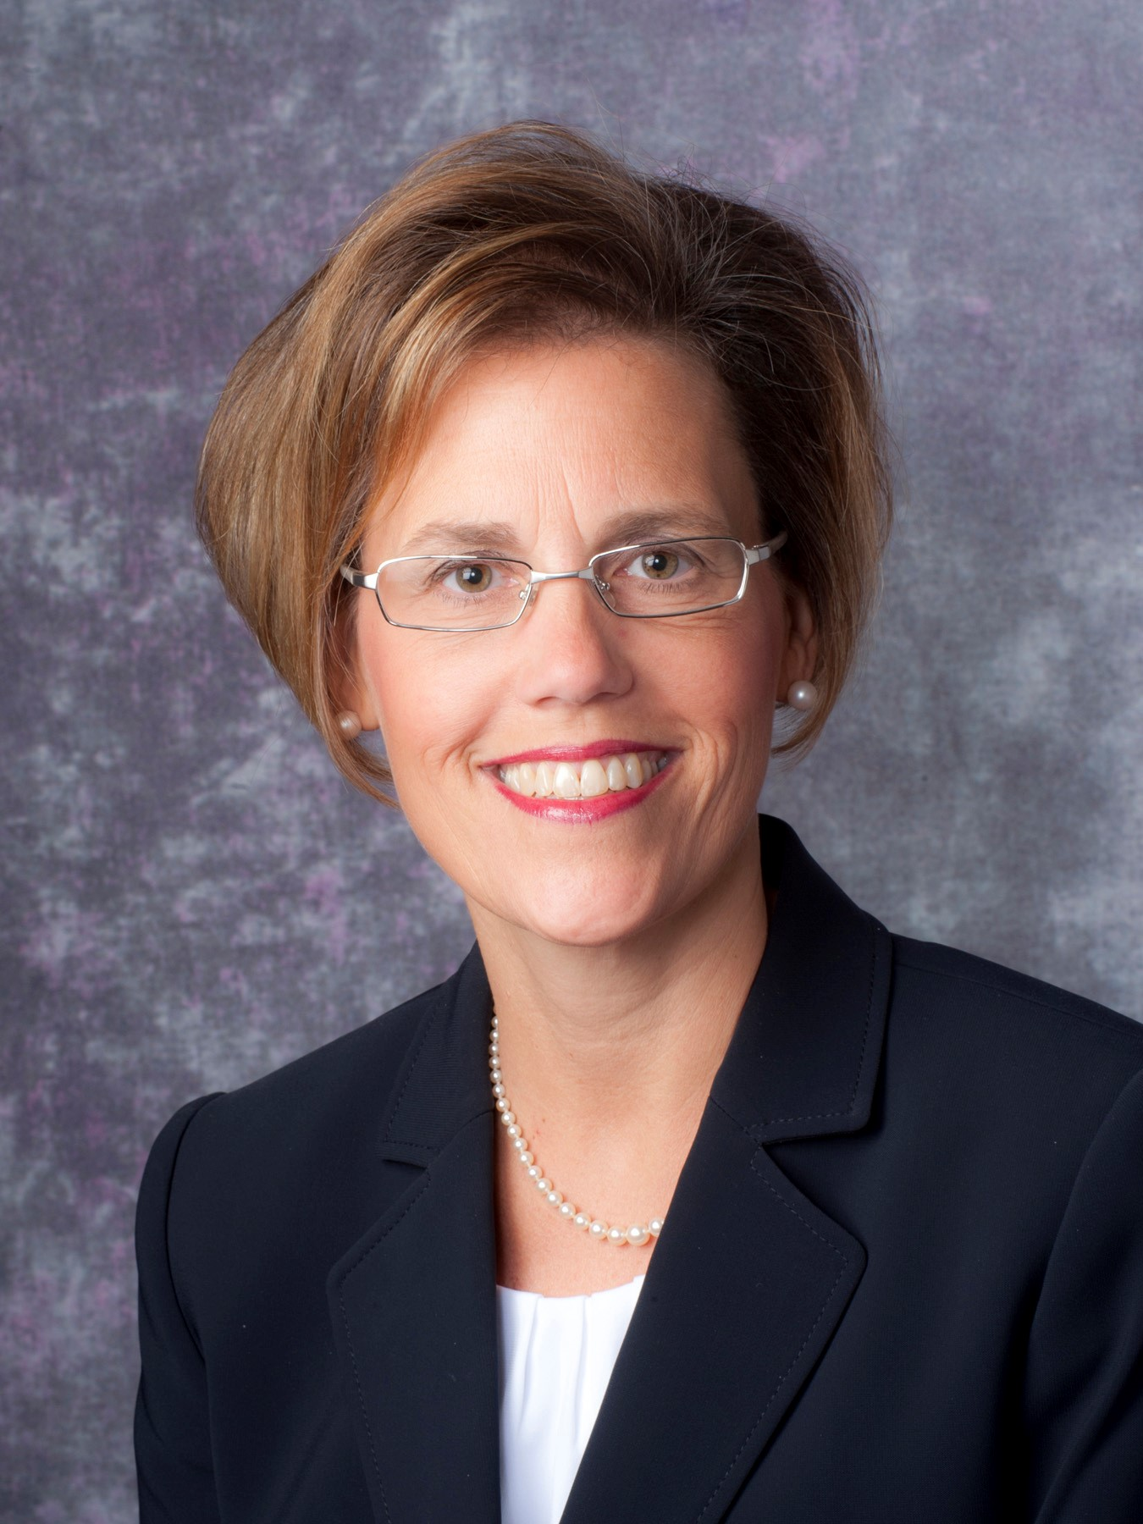  PAST CHAIR (Nominations chair)  Diane S. Hupp, DNP, RN, NEA-BC  Children’s Hospital of Pittsburgh of UPMC  diane.hupp@chp.edu
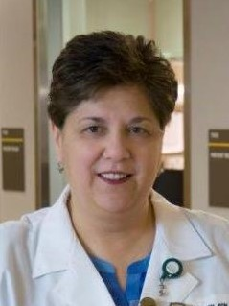  CHAIR ELECT  Jacqueline Collavo, MA, BSN, RN, NE-BC  Vice President/Chief Nursing Officer  West Penn Hospital  Allegheny Health Network  Jacqueline.COLLAVO@AHN.org | 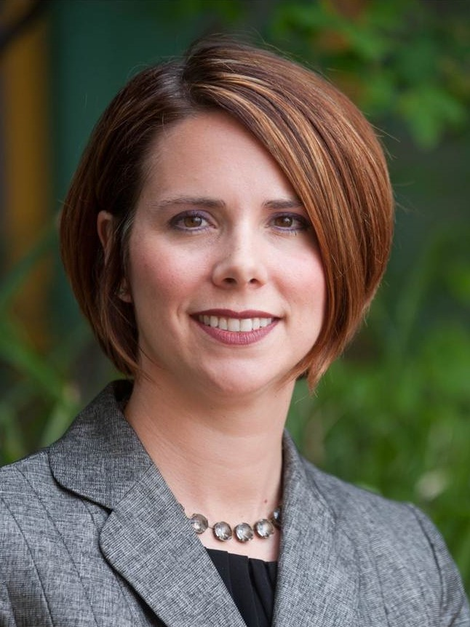  SECRETARY/TREASURER  Heather Ambrose, DNP, RN, CPON, CPN (2020)  Children’s Hospital of Pittsburgh of UPMC  Heather.ambrose@chp.edu
SWPONL Board of Directors
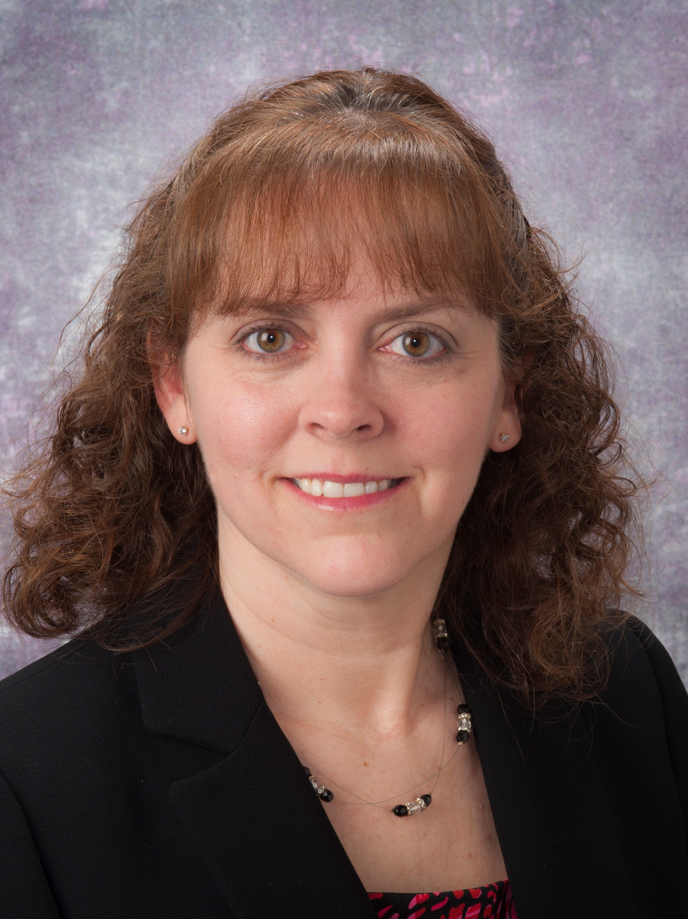  Denise Abernethy, MSN, RN, CEN (2018)  UPMC St. Margaret  abernethydm@upmc.edu |   Jacqueline Joyce Drahos, MSN, RN (2018)  UPMC Jameson  drahosjj@upmc.edu | 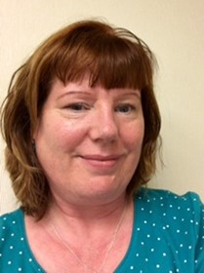  Louise Dobbins, BSN, MHA, FACHE (2019)  Allegheny General Hospital  louise.dobbins@ahn.org
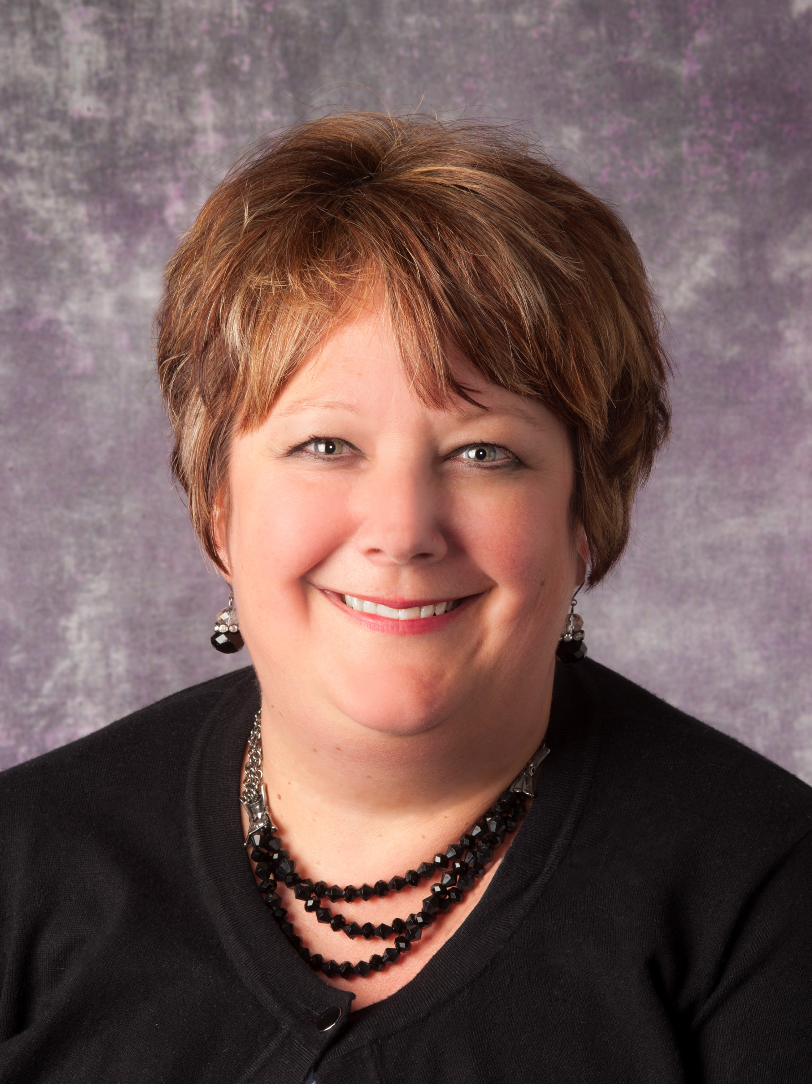  Diane Cancilla, MSN, RN, NEA-BC (2020)  Children’s Hospital of Pittsburgh, Of UPMC  Diane.cancilla@chp.edu | 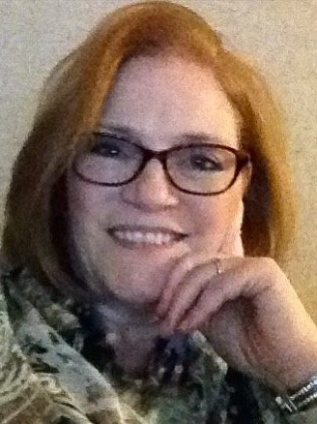  Beth Savage, RN, MSN, PhD, NEA-BC, RN-BC (2020)  UPMC St Margaret  savageba3@upmc.edu | 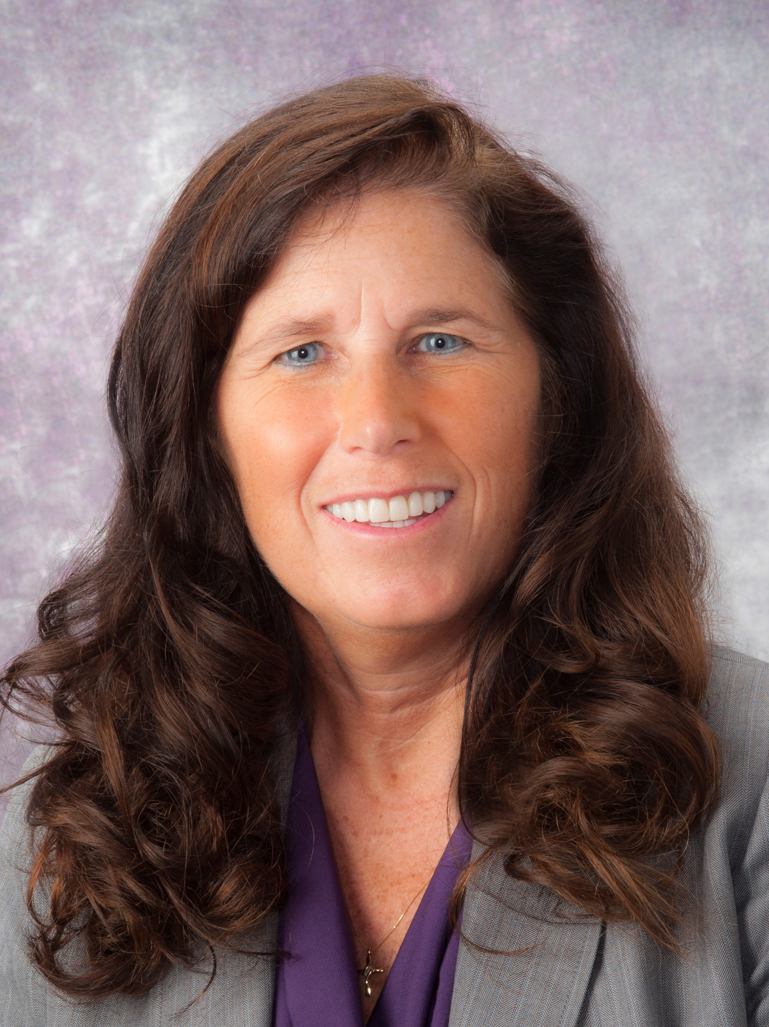  Jill Marie Larkin RN, MSN, MBA, DNP, CMQ/OE (2019)  UPMC, Center of Nursing Excellence  larkinjm@upmc.edu
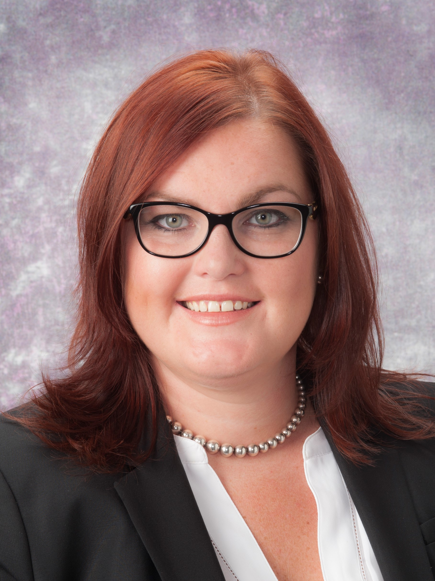  Aimee Skrtich, DNP, RN, CCRN, NE-BC (2020)  University of Pittsburgh Physicians  skrticha@upmc.edu | 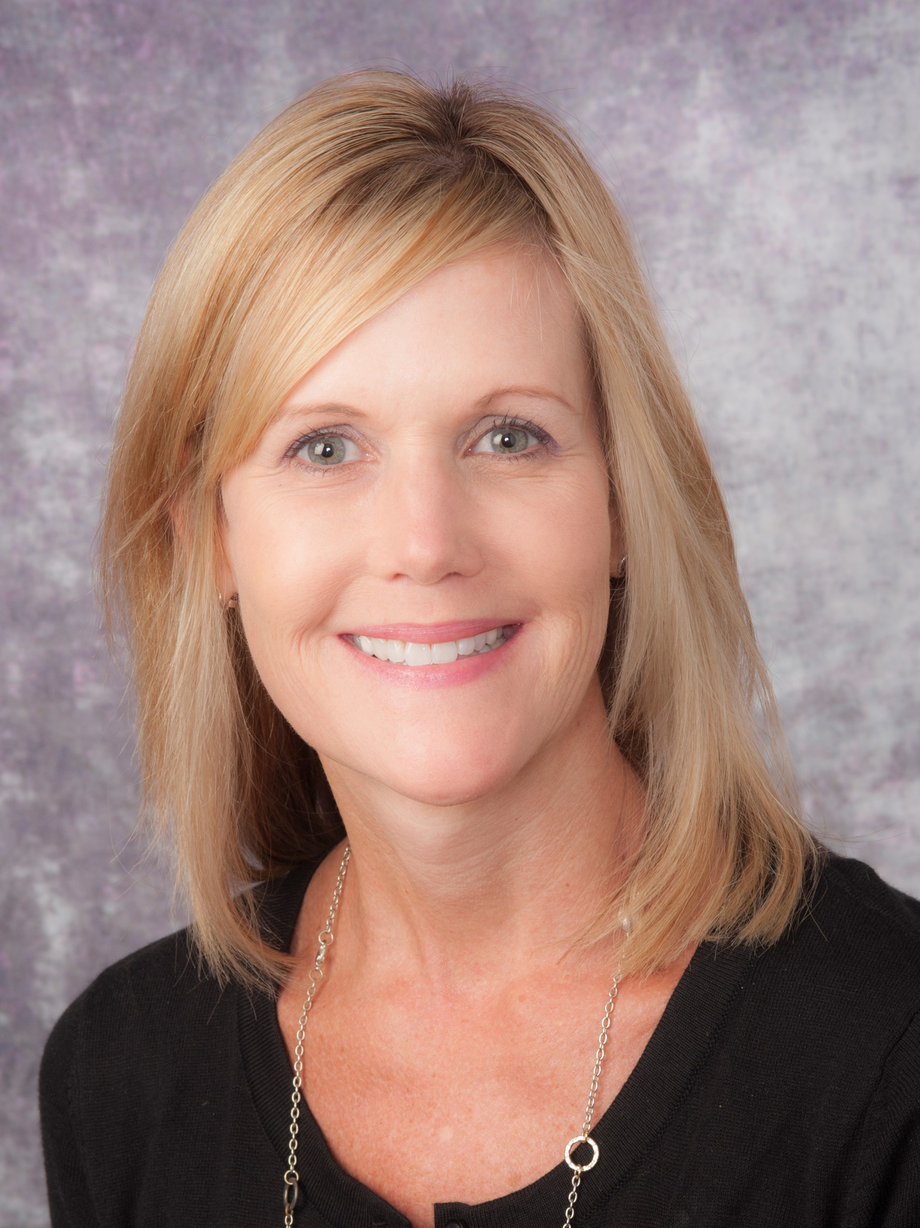  Robin L. Myers, MSN, CRNP (2018)  UPMC Mercy  myersrl@upmc.edu |   Robin R. Weaver, PhD, RN, CNE (2020)  California University of Pennsylvania  weaver_r@calu.edu
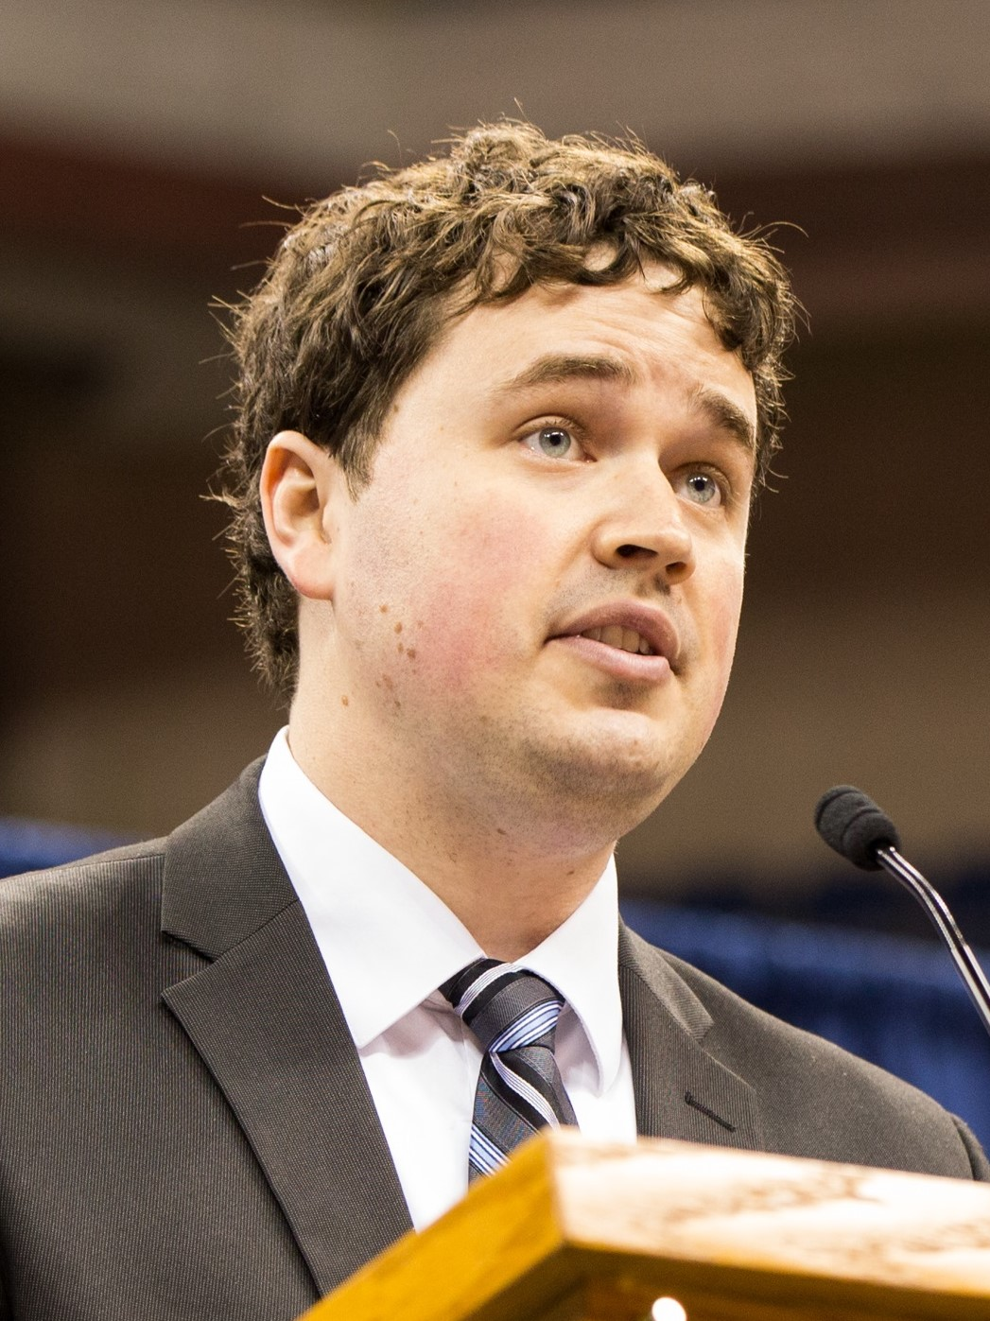  Michael Simon  (SWPONL Emerging Leader started 2017)  Allegheny General Hospital  Michael.simon@ahn.org | 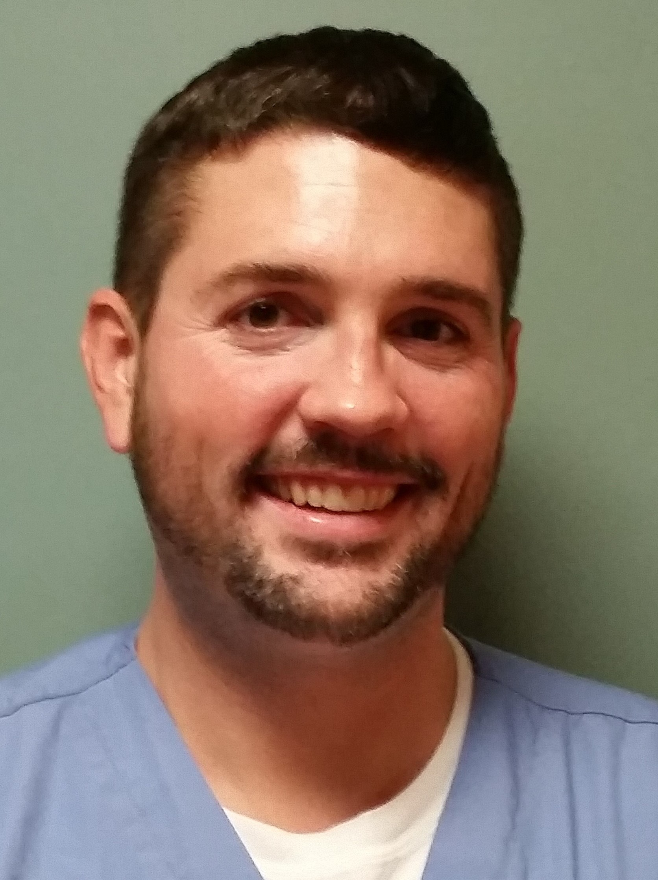  Joseph A. Barkovich, BA, MSN, RN (PONL Emerging Leader started 2017)  VA Pittsburgh Healthcare System  barkovich.joe@gmail.com | 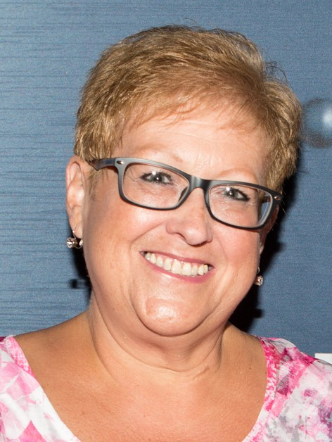  EDUCATION CHAIR  Deborah Vehec, MSN, RN  Central Blood Bank  dvehec@itxm.org

MEMBERSHIP CHAIR
Michele Carlson, MSN, RN, CPN
Children's Hospital of Pittsburgh of UPMC
michele.carlson@chp.edu

